SMART **PARKING**

***ANN(Artificial Neural Networks)Algorithm***

A multiple linear regression model and an ANN Multilayer Perceptron. We first present the results of multiple linear regression. The dependent variable is the percentage of voters who declared their intention to abstain or who declared their regarding the election choice (label ‘no-VOt’). The independent variables are the following four: the duration of the poll in days (label ‘days’); the sample size (label ‘n-sample’); the completeness index of the information relating to the poll (label ‘ind-1′); the ratio between the interview attempts and the interviews carried out (‘ind-2′). Table  2 presents the results of the multiple regression model. Considering the adjusted R square, we fnd that the four independent variables reproduce a little less than a third (31.1%) of the variance of the dependent variable. Table 3 shows the regression co-effcients.

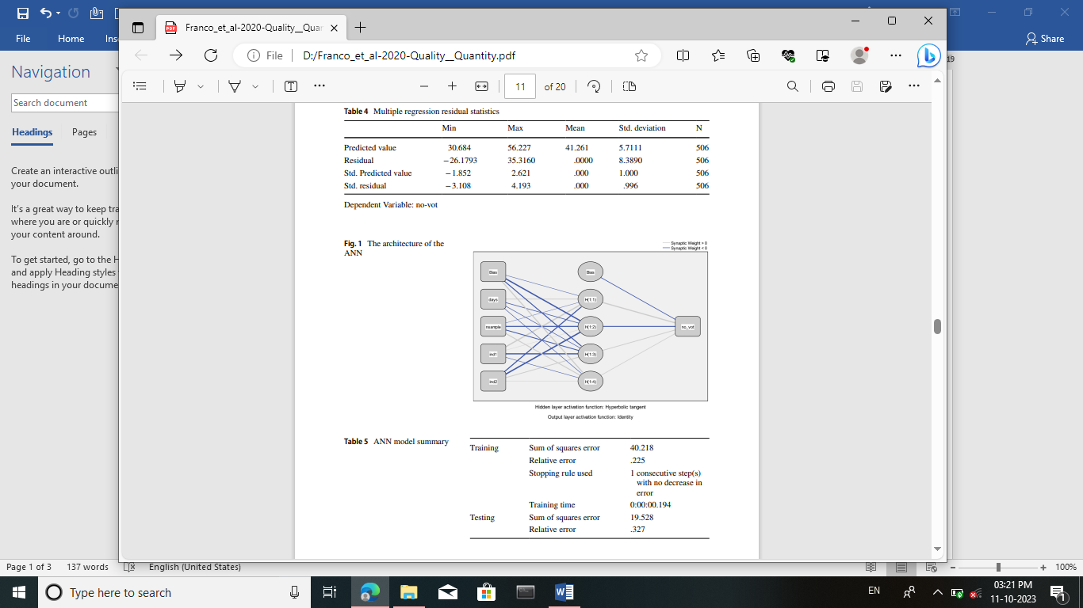

Let’s now evaluate the results obtained with the  ANN comparing them with those obtained with the multiple linear regression (Fig. 1).3 The cases submitted to the network are obviously the same 506 used in the regression. In this case, however, 70% of cases (359) were used in the training set and the remaining 30% (147) in the testing set. Table 5 presents the model summary. In the training set the relative error was equal to .225. In the testing set it grows slightly reaching the value of .327. Recall that in the testing set the network predicts the value of the dependent variable using the weights that it computed on the cases observed during the training. So basically, we assess the ability of the network to generalize what it has learned in the training. We do not report the parameter estimates (i.e. the weights calculated for each node of the network) as their examination does not clarify the impact of each independent variable in the estimate of the dependent one. The comparison between the results of the multiple regression and the ANN leaves no doubt about the better predictive performance of the network (Table 6). The between the values predicted by the multiple regression and the actual values of the dependent variable is equal to .563; the correlation between the values predicted by the ANN and the actual values of the dependent variable is thirty points higher, rising to .866. Evidently in the relationship between the independent variables and the dependent one, the network managed to capture nonlinear trends which allow for a better estimate of the

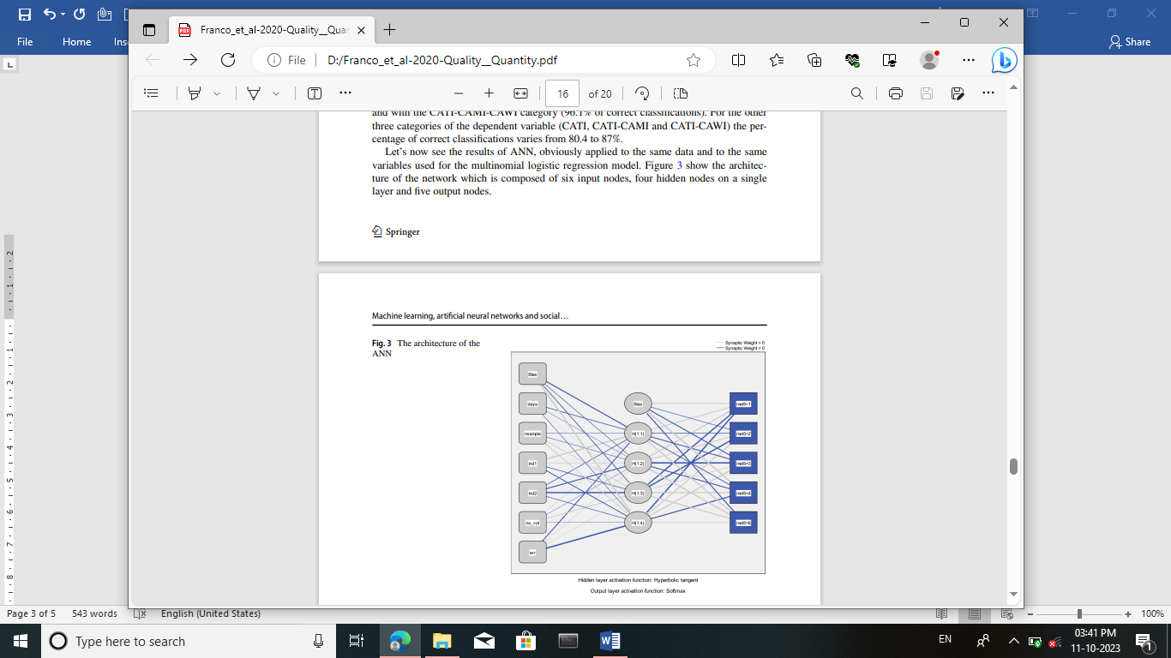  
Also in the third example the ANN results are better than those of the multinomial logistic regression model. On the whole, if we consider the results of the training, ANN reaches 94.5% of correct classifcations against 92.3% of the multinomial model. Even if we take into consideration the results of ANN testing, they are, albeit slightly, better (93.2%). As for the single categories of the dependent variable, ANN achieves the best performance with the panel category (100% of correct classifcations for both training and testing set) and with the CATI-CAMI-CAWI category (96.9% for the training set and 94.1% for the testing set). For the other three categories of the dependent variable (CATI, CATI-CAMI and CATICAWI) the percentage of correct classifcations varies from 86.5 to 91.2% for the training set and from 82.6 to 93.1% for the testing set